Attributes

🌟 Definition
# Source: AI Source: Provided by: [Data Path: Persons Table -> ID Column: 1, Name_En Column: Motasem Essam] -> From: [ChatGPT] on [6/10/2026]
An Attribute is a property, characteristic, or piece of information that describes an entity.
Attributes provide the details stored about an entity.

🎯 Purpose
# Source: AI Source: Provided by: [Data Path: Persons Table -> ID Column: 1, Name_En Column: Motasem Essam] -> From: [ChatGPT] on [6/10/2026]
Attributes help answer:
- What information should be stored about an entity?
- What details describe the entity?
- What data fields are needed?

🧠 Simple Example
# Source: AI Source: Provided by: [Data Path: Persons Table -> ID Column: 1, Name_En Column: Motasem Essam] -> From: [ChatGPT] on [6/10/2026]
Entity
Customer
Attributes
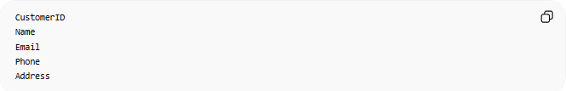
CustomerID
Name
Email
Phone
Address
Here:
- Customer = Entity
- CustomerID, Name, Email, Phone, Address = Attributes

📚 Real-World Examples
# Source: AI Source: Provided by: [Data Path: Persons Table -> ID Column: 1, Name_En Column: Motasem Essam] -> From: [ChatGPT] on [6/10/2026]
Customer Entity
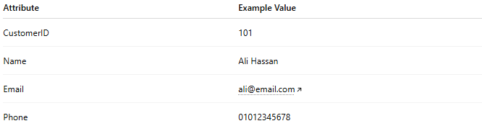
Attribute | Example Value
CustomerID | 101
Name | Ali Hassan
Email | ali@email.com
Phone | 01012345678

Product Entity
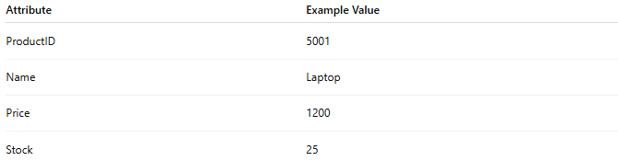
Attribute | Example Value
ProductID | 5001
Name | Laptop
Price | 1200
Stock | 25

Student Entity
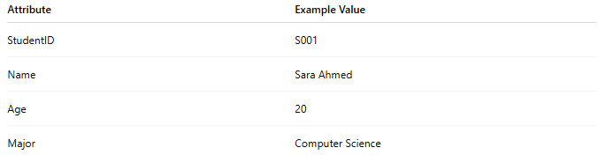
Attribute | Example Value
StudentID | S001
Name | Sara Ahmed
Age | 20
Major | Computer Science

🔢 Characteristics of Attributes
# Source: AI Source: Provided by: [Data Path: Persons Table -> ID Column: 1, Name_En Column: Motasem Essam] -> From: [ChatGPT] on [6/10/2026]
An attribute:
- Describes an entity
- Stores data values
- Has a name
- Has a data type
- May have constraints

🗄️ Attribute → Database Column
# Source: AI Source: Provided by: [Data Path: Persons Table -> ID Column: 1, Name_En Column: Motasem Essam] -> From: [ChatGPT] on [6/10/2026]
In relational databases, attributes usually become columns.
Entity
Customer
Table
CustomerID | Name | Email
1 | Ali | ali@email.com
Here:
- Customer = Table (Entity)
- CustomerID, Name, Email = Columns (Attributes)

📊 ER Diagram Representation
# Source: AI Source: Provided by: [Data Path: Persons Table -> ID Column: 1, Name_En Column: Motasem Essam] -> From: [ChatGPT] on [6/10/2026]
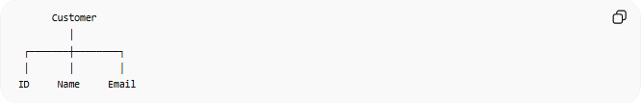
Customer
│
┌───────┼────────┐
│ │ │
ID Name Email
- Customer = Entity
- ID, Name, Email = Attributes

🏷️ Types of Attributes

1. Simple Attribute
# Source: AI Source: Provided by: [Data Path: Persons Table -> ID Column: 1, Name_En Column: Motasem Essam] -> From: [ChatGPT] on [6/10/2026]
Cannot be divided further.
Example:
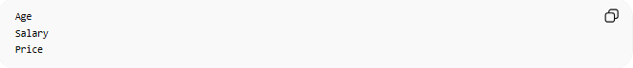
Age
Salary
Price

2. Composite Attribute
# Source: AI Source: Provided by: [Data Path: Persons Table -> ID Column: 1, Name_En Column: Motasem Essam] -> From: [ChatGPT] on [6/10/2026]
Can be divided into smaller parts.
Example:
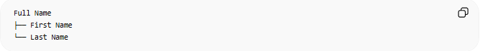
Full Name
├── First Name
└── Last Name

3. Multi-Valued Attribute
# Source: AI Source: Provided by: [Data Path: Persons Table -> ID Column: 1, Name_En Column: Motasem Essam] -> From: [ChatGPT] on [6/10/2026]
Can have multiple values.
Example:
Phone Numbers
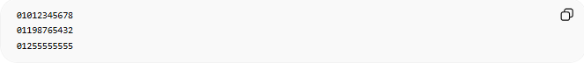
01012345678
01198765432
01255555555

4. Derived Attribute
# Source: AI Source: Provided by: [Data Path: Persons Table -> ID Column: 1, Name_En Column: Motasem Essam] -> From: [ChatGPT] on [6/10/2026]
Calculated from other attributes.
Example:
DateOfBirth → Age
Age is derived from DateOfBirth.

🔑 Key Attributes
# Source: AI Source: Provided by: [Data Path: Persons Table -> ID Column: 1, Name_En Column: Motasem Essam] -> From: [ChatGPT] on [6/10/2026]
Some attributes uniquely identify an entity.
Example:
CustomerID
This is often the Primary Key.
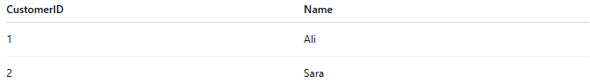
CustomerID | Name
1 | Ali
2 | Sara
No two customers can have the same CustomerID.

⚠️ Attribute vs Entity
# Source: AI Source: Provided by: [Data Path: Persons Table -> ID Column: 1, Name_En Column: Motasem Essam] -> From: [ChatGPT] on [6/10/2026]
Entity
Customer
Represents a thing.
Attribute
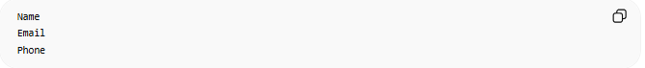
Name
Email
Phone
Represents information about that thing.

Example
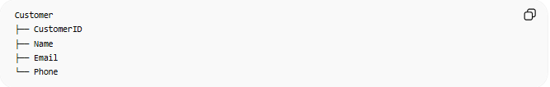
Customer
├── CustomerID
├── Name
├── Email
└── Phone
- Customer = Entity
- CustomerID, Name, Email, Phone = Attributes

🌍 Real-World Example
# Source: AI Source: Provided by: [Data Path: Persons Table -> ID Column: 1, Name_En Column: Motasem Essam] -> From: [ChatGPT] on [6/10/2026]
Online Store:
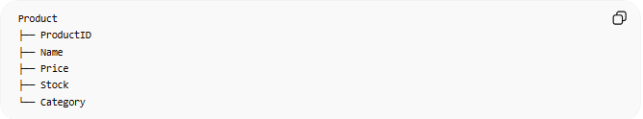
Product
├── ProductID
├── Name
├── Price
├── Stock
└── Category
Entity:
Product
Attributes:
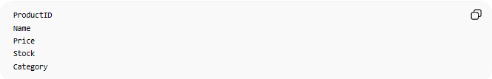
ProductID
Name
Price
Stock
Category

🧠 Simple Analogy
# Source: AI Source: Provided by: [Data Path: Persons Table -> ID Column: 1, Name_En Column: Motasem Essam] -> From: [ChatGPT] on [6/10/2026]
Think of an entity as a person’s profile.
Person
The attributes are the details on that profile:
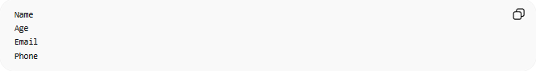
Name
Age
Email
Phone
The profile is the entity; the details are the attributes.

🧭 Summary
# Source: AI Source: Provided by: [Data Path: Persons Table -> ID Column: 1, Name_En Column: Motasem Essam] -> From: [ChatGPT] on [6/10/2026]
An Attribute is a property or characteristic that describes an entity. In a relational database, attributes typically become table columns and store the specific details about each entity instance.

